**GOVU**

**MALLESH**

**YADAV**

H.No

1-25/1

,Padmaram

chowdergudem

,Rangareddy,

Telangana-509207

Email:malleshyadav398@gmail.com

Mobile:

+91-8185094318

+91-7989428190

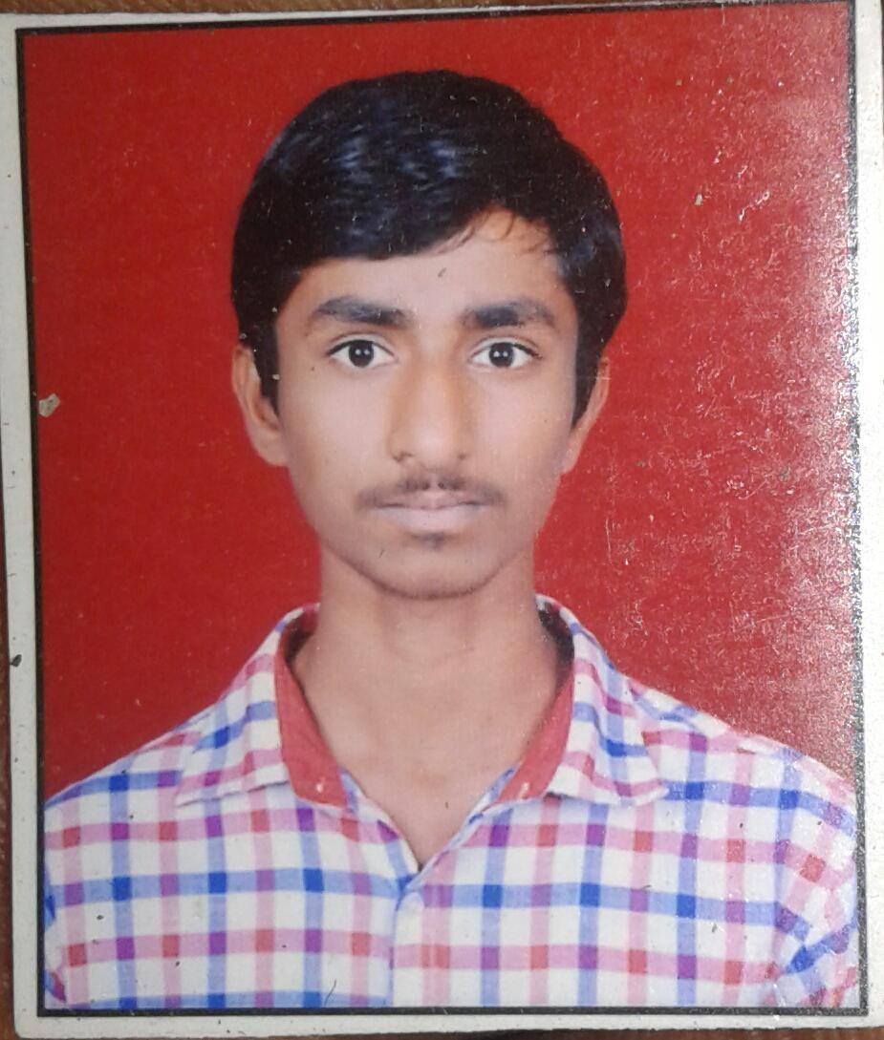

**OBJECTIVE:**

To obtain a satisfying, interesting and an innovative post in an esteemed organisation which will help to establish my career.

**EDUCATIONAL QUALIFICATIONS:**

* **Bachelor of Technology** in **IT** from **Mahaveer Institute of Science and Technology ,** Hyderabad 2022-2025 CGPA: 7.2 (till now)
* **Diploma** in **Mechanical Engineering** from **VNR Vignana Joythi Institute of Engg. and Tech.,** , Hyderabad in 2018 Aggregrate :73.8%

**Secondary School Certificate from Nava jyothi high** school, shadnagar in 2015; Score 8.8 GPA

**ACEDAMIC PROJECT:**

Investigation of turning parameters for high speed dry turning of superalloys.

**Technical Skills**

* Well versed with MS Word,MS Excel,MS PowerPoint
* Basic knowledge of AUTO CAD
* Practical exposure different machines.
* C , C++
* Java
* Python

**Achievements And Other Works**

Achieved an academic aggregate 73.8% in Diploma.

**Personal Traits**

* Time management and problem solving skills along with the desire to learn more.
* Adaptable to any kind of machine,hardware and software.
* Quick learner and innovative.

**Personal Details**

|  |  |
| --- | --- |
| Father s Name | : G.Narsimulu |
| Mother s Name | : G. Anjamma |
| Date of Birth | : 11/11/1999 |
| Languages Known | : English, Hindi, Telugu. |

Hobbies : watching science related shows

Strengths : Adaptable to new things

**LOOKING FORWARD FOR A GOOD OPPURTUNITY IN YOUR ESTEEMED**

**ORGANISATION**

**GOVU Mallesh yadav**

**Place: Hyderabad Date: 28/09/2024**